Chapter 16, Problem 96.

Show that the parallel RLC circuit shown in Fig. 16.105 is stable.

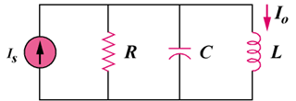

Figure 16.105
For Prob. 16.96.

